Prechordal plate
- It is a transient, thickened region of the cranial epiblast in the bilaminar embryonic disc.
- Serves as the rostral organizer for head and forebrain development.
- It precedes the notochord and plays a pivotal role in gastrulation
- It establishes the anterior-posterior (A-P) axis through SHH-dependent inhibition of BMP/Wnt signaling,
- Ensures proper telencephalon and eye field formation.
[TIP]Prechordal plate cells are pioneer ingressor cells via RhoA/ROCK cytoskeleton, with Eph/ephrin guiding rostral path
RhoA/ROCK signaling pathway is essential for the apical constriction and force generation required for individual cells to ingress through the primitive streak/node, a process that involves epithelial-to-mesenchymal transition (EMT).
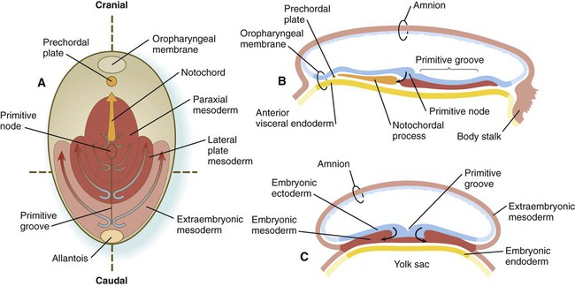
[CLINICAL]Epigenetic Regulation: H3K4me3 marks activate SHH in prechordal cells, linking maternal folate to methylation for defect prevention
H3K4me3 is a central epigenetic mediator in the prevention of neural tube defects (NTDs) by maintaining appropriate transcriptional programs during embryogenesis.

Transgenerational Epigenetic Stability
Folate levels in parents (specifically paternal folate) are critical for ensuring the fidelity of the sperm epigenome:
- Paternal Transmission: Folate deficiency alters H3K4me3 marks in sperm at specific developmental loci and enhancers.
- Embryonic Priming: These aberrant H3K4me3 marks can be transmitted to the embryo and are retained during early cleavage stages. Adequate folate prevents these "epigenetic errors" from accumulating, thereby ensuring that early embryonic genes are expressed at the correct timing and magnitude.

Defects Linked to H3K4me3/Folate Imbalance
- Anencephaly: Failure of the cranial neural tube to close.
- Spina Bifida: Failure of the caudal neural tube to close.

